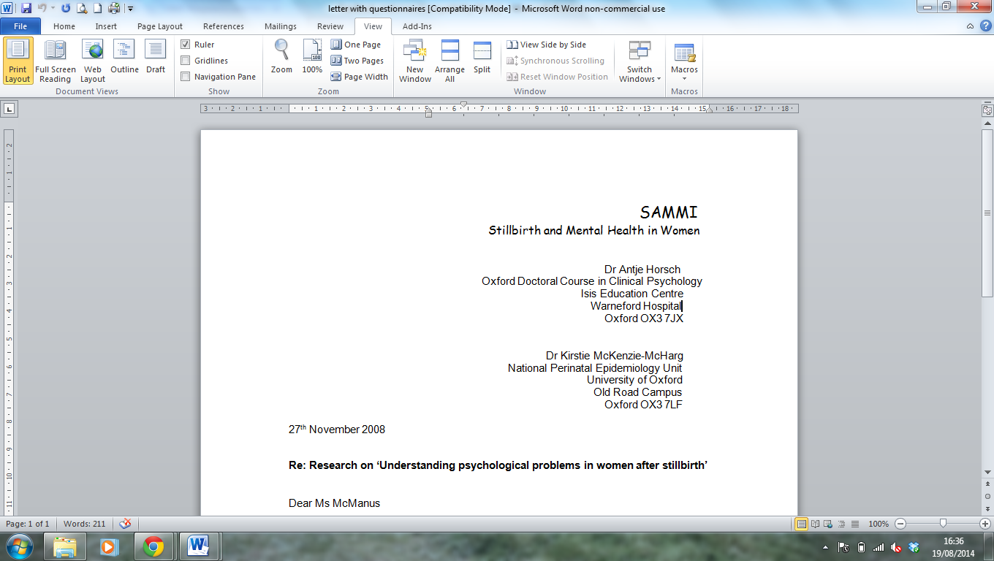Stillbirth and Mental Health in Women study
Summary of study findings

The guidelines about what contact mothers should choose to have with their stillborn infant following a stillbirth have been contradictory over the past thirty years. Most have reported that seeing and holding their baby is associated with fewer mental health symptoms among mothers of stillborn babies than not doing so. In contrast, others suggest that having contact with the stillborn infant can have a negative impact on the mothers’ mental health.

There is a lack of research focusing on the contact and experience that mothers have had with their stillborn infant. This study aimed to investigate how mothers describe their experience of spending time with their stillborn baby and how they felt later about the decision they made to see and hold their baby or not. In depth interviews were conducted with 21 mothers in their homes three months after they had a stillbirth. All the interviews were recorded and lasted between 20 and 30 minutes. The interviews were transcribed and pseudonyms added to ensure confidentiality. The interview data was analysed to identify key themes.

Twenty-one mothers with a mean age of 34.4 years were interviewed. Stillbirths occurred on average at 35.17 weeks gestational age. All mothers saw their stillborn baby and 19 mothers (90.5%) held their baby. Mothers had on average been pregnant twice (including their recent stillbirth). Before the stillbirth, three (14%) of the mothers interviewed had had a miscarriage, four (19%) had had a termination and one mother (4.8%) had had a previous stillbirth.

Mothers talked about the importance of having time with their baby and being able to share the experience with those around them. Although it was extremely difficult at the time, spending time with their baby was a helpful experience and the majority of mothers valued the time they had. Many participants also spoke about being able to share their experience with their partner and also with parents and members of their extended family. Involving those around them after the stillbirth was an important part of the process for some mothers.
A number of women described their concern about seeing a dead body. They expressed worry about what the baby would look like, as well as about how they would feel in response to being faced with a dead child. Consequently, a number of mothers felt a great sense of relief when they realised their baby was well-formed. However, a few women spoke about the damage to their baby’s body and how difficult this was for them. Whilst most mothers found the physical appearance and seeing their stillborn baby a positive experience, helping them feel better about seeing the baby and the excitement of comparing the baby to family members, some mothers whose baby’s body had been damaged struggled with seeing or holding their baby.

Mothers spoke at length about the emotional impact of having a stillbirth, including feelings of pride at having a child, the intense pain and grief they felt at losing their child and the positive process that followed for some mothers. Whilst acknowledging intense sadness and loss following a stillbirth, a number of mothers described how the experience of seeing their baby had been a positive one and the fond memories they held of the time they spent with their baby. Some mothers also spoke of their pride at becoming a mother, and a positive change in how they felt about the stillbirth at the point of holding their baby for the first time. When looking back and describing the experience of spending time with their baby, the words “distraught”, “heart-breaking”, “angry” “pain” and “helpless” were over-riding expressions linked to grief used by participants.

As well as finding the experience of seeing their baby after the stillbirth emotional, a number of mothers also described the experience as surreal. Several women described feelings of disbelief. Others reported feelings of dissociation and described the experience as “blurred like it was a dream” and “like looking at a doll.....not a baby. Not like mine but somebody else’s”. Similarly, some mothers spoke about feeling disconnected from what they had experienced. For a few women, having a stillbirth resulted in strong feelings of disconnection from the world around them.

Having the opportunity to say goodbye and seeing the baby helped to bring about the realisation and acceptance for many mothers that their baby had died. One mother explained “I needed to say goodbye to her and I needed to say sorry”, sentiments echoed by a number of other mothers when looking back at the time they spent with their baby. Participants also reported that seeing their baby following a stillbirth “helps you to cope with what’s happened”, as well as to accept that the baby had died. Having the opportunity to say goodbye and to see their baby brought about a sense of finality that for many mothers contributed to the healing process. It was something they felt they needed to do in order to move forward.

Although most mothers felt satisfied with their decision to see their baby following the stillbirth, a few mothers reported strong feelings of regret about the decision they took to not hold their stillborn baby. One mother also spoke of her sadness that her partner chose not to see their stillborn baby and the loss of shared experience as a family. For the majority of mothers, the decision to see their stillborn baby was crucial to their ability to accept what had happened and to say goodbye, and then to move forward.

We concluded that it is important to involve parents in all decisions regarding their contact with their stillborn baby. Our results indicate that preparation before having contact with the baby, professional support during the contact, and professional follow-up are crucial to prevent the development of maternal mental health problems. Giving parents an informed choice is crucial. Consistent with previous research, our findings suggest that it may be appropriate for staff to recommend to parents that they consider having contact with their stillborn baby.

For more details, please see the recently published article:
http://www.biomedcentral.com/1471-2393/14/203

If you have any queries regarding this study or would like to discuss any of these findings in more detail, please do not hesitate to contact us:

Dr Antje Horsch (Clinical Psychologist and Principal Investigator): antje.horsch@chuv.ch

Dr Kirstie McKenzie-McHarg (Consultant Clinical Psychologist and Co-Investigator): Kirstie.McKenzie-McHarg@swft.nhs.uk

